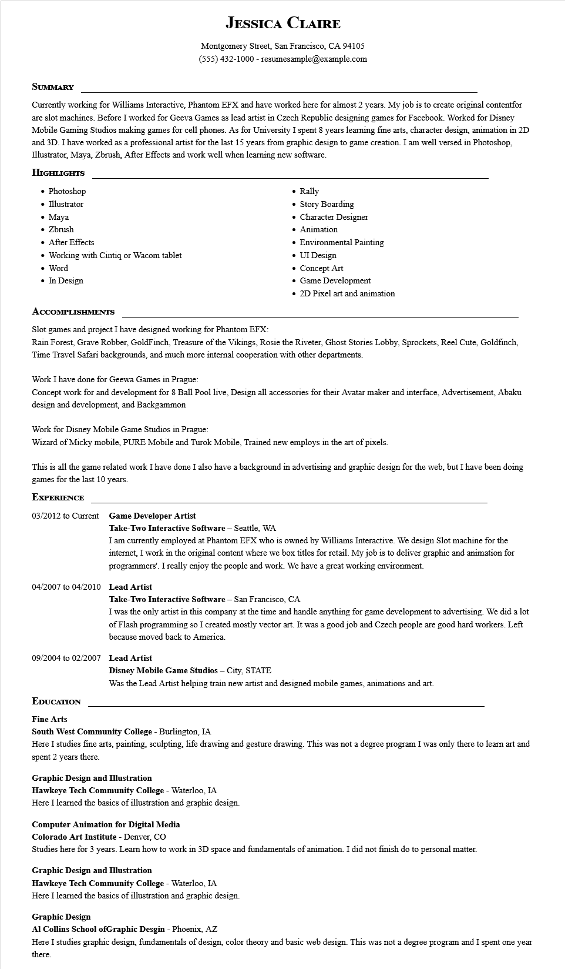
JESSICA CLAIRE
Montgomery Street, San Francisco, CA 94105
(555) 432-1000 - resumesample@example.com
SUMMARY
Currently working for Williams Interactive, Phantom EFX and have worked here for almost 2 years. My job is to create original contentfor are slot machines. Before I worked for Geeva Games as lead artist in Czech Republic designing games for Facebook. Worked for Disney Mobile Gaming Studios making games for cell phones. As for University I spent 8 years learning fine arts, character design, animation in 2D and 3D. I have worked as a professional artist for the last 15 years from graphic design to game creation. I am well versed in Photoshop, Illustrator, Maya, Zbrush, After Effects and work well when learning new software.
HIGHLIGHTS
⚫ Photoshop
• Illustrator
• Maya
• Zbrush
• After Effects
• Working with Cintiq or Wacom tablet
Word
• In Design
ACCOMPLISHMENTS
Slot games and project I have designed working for Phantom EFX:
• Rally
• Story Boarding
• Character Designer
• Animation
• Environmental Painting
• UI Design
• Concept Art
• Game Development
• 2D Pixel art and animation
Rain Forest, Grave Robber, GoldFinch, Treasure of the Vikings, Rosie the Riveter, Ghost Stories Lobby, Sprockets, Reel Cute, Goldfinch, Time Travel Safari backgrounds, and much more internal cooperation with other departments.
Work I have done for Geewa Games in Prague:
Concept work for and development for 8 Ball Pool live, Design all accessories for their Avatar maker and interface, Advertisement, Abaku design and development, and Backgammon
Work for Disney Mobile Game Studios in Prague:
Wizard of Micky mobile, PURE Mobile and Turok Mobile, Trained new employs in the art of pixels.
This is all the game related work I have done I also have a background in advertising and graphic design for the web, but I have been doing games for the last 10 years.
EXPERIENCE
03/2012 to Current Game Developer Artist
Take-Two Interactive Software - Seattle, WA
I am currently employed at Phantom EFX who is owned by Williams Interactive. We design Slot machine for the internet, I work in the original content where we box titles for retail. My job is to deliver graphic and animation for programmers'. I really enjoy the people and work. We have a great working environment.
04/2007 to 04/2010 Lead Artist
Take-Two Interactive Software - San Francisco, CA
I was the only artist in this company at the time and handle anything for game development to advertising. We did a lot of Flash programming so I created mostly vector art. It was a good job and Czech people are good hard workers. Left because moved back to America.
09/2004 to 02/2007 Lead Artist
Disney Mobile Game Studios - City, STATE
Was the Lead Artist helping train new artist and designed mobile games, animations and art.
EDUCATION
Fine Arts
South West Community College - Burlington, IA
Here I studies fine arts, painting, sculpting, life drawing and gesture drawing. This was not a degree program I was only there to learn art and spent 2 years there.
Graphic Design and Illustration
Hawkeye Tech Community College - Waterloo, IA
Here I learned the basics of illustration and graphic design.
Computer Animation for Digital Media
Colorado Art Institute - Denver, CO
Studies here for 3 years. Learn how to work in 3D space and fundamentals of animation. I did not finish do to personal matter.
Graphic Design and Illustration
Hawkeye Tech Community College - Waterloo, IA
Here I learned the basics of illustration and graphic design.
Graphic Design
Al Collins School ofGraphic Desgin - Phoenix, AZ
Here I studies graphic design, fundamentals of design, color theory and basic web design. This was not a degree program and I spent one year there.

